Perform clustering (Both hierarchical and K means clustering) for the airlines data to obtain optimum number of clusters.
Draw the inferences from the clusters obtained.
Data Description:
The file EastWestAirlinescontains information on passengers who belong to an airlineâ€™s frequent flier program. For each passenger the data include information on their mileage history and on different ways they accrued or spent miles in the last year. The goal is to try to identify clusters of passengers that have similar characteristics for the purpose of targeting different segments for different types of mileage offers
ID --Unique ID
Balance--Number of miles eligible for award travel
Qual_mile--Number of miles counted as qualifying for Topflight status
cc1_miles? CHAR--Has member earned miles with airline freq. flyer credit card in the past 12 months (1=Yes/0=No)?
cc2_miles? CHAR--Has member earned miles with Rewards credit card in the past 12 months (1=Yes/0=No)?
cc3_miles? --Has member earned miles with Small Business credit card in the past 12 months (1=Yes/0=No)?
Bonus_miles--Number of miles earned from non-flight bonus transactions in the past 12 months
Bonus_trans--Number of non-flight bonus transactions in the past 12 months
Flight_miles_12mo--Number of flight miles in the past 12 months
Flight_trans_12--Number of flight transactions in the past 12 months
Days_since_enrolled--Number of days since enrolled in flier program
Award--whether that person had award flight (free flight) or not

Answer:
In eastwest airlines dataset,the observations are around 4000,so this is large dataset.Analysing the group of persons get award or not.it was analysed by some other attributes like flight travelled in past 12 months,bonus transcations or bonus miles.

Normalisation:
Normalising the datas in all columns of eastwestairlines dataset.
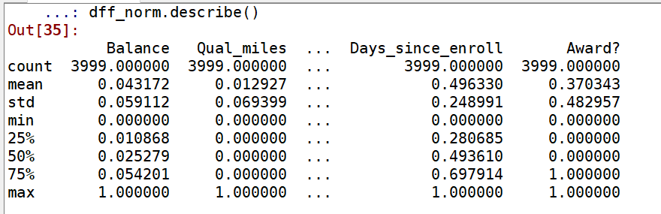

Importing Linkage Function:-
Apply linkage functions to normalised dataset.
Method : Complete(measures one point of one cluster to farthest point of another cluster)
Metric : Euclidean(performs hierarchical clustering)

Ploting Dendogram:-
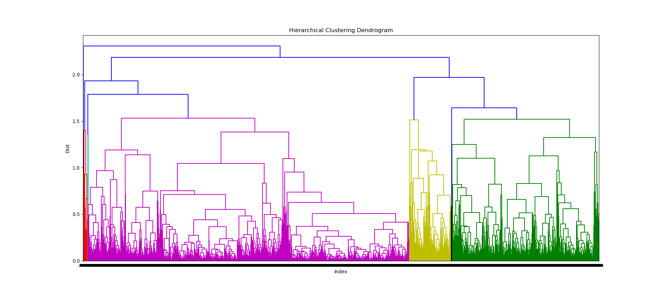

Import Agglomerative Clustering:-
Apply agglomerative clustering on normalised datas,for my analysis i take n clusters as 10,there formed 10 different clusters.In these clusters identify a output as properly.
Add clusters to input variables.

Output:-
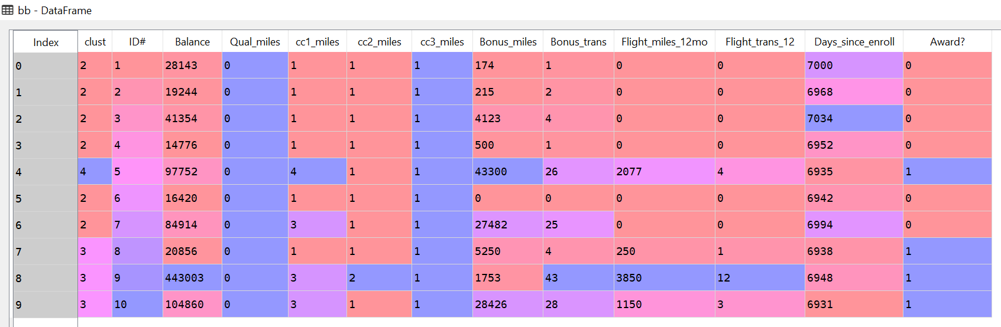
if the persons have travelled last 12 months only be awarded.
Always bonus transcations and bonus miles considered and travelled in last 12 months only they are be awarded.

K-means Clustering:-
In k-means clustering,we will give how much clusters want,applied in first step.take clusters as 10.

Total within sum of squares for each k-means:
Appling a total within sum of squares for each K-means with no.of clusters.
However we get result before we applying a within sum of squares of datasets by Euclidean distance.
Plotting twss vs Clusters:-
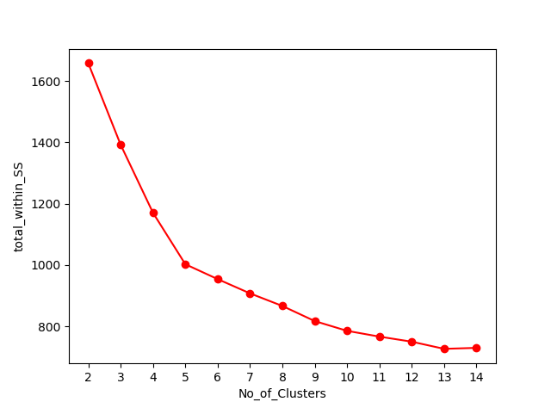

then model was prepared.

Output:-
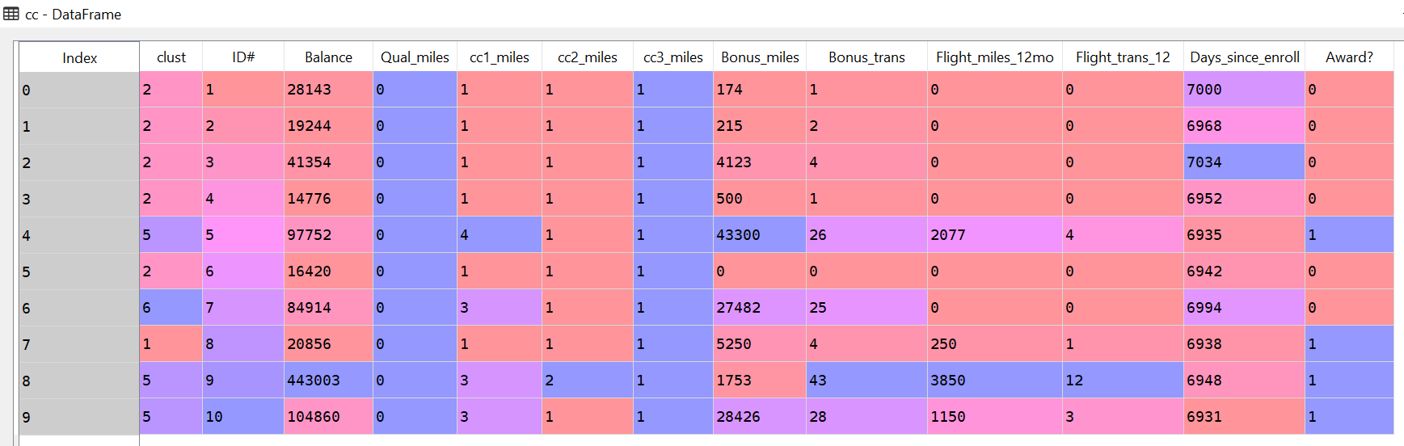
In k-means clustering always shows a same result.if the persons have travelled last 12 months only be awarded.

